**Software Requirements Specification (SRS)**

**Bike Ecommerce Store**

**Team Members**

|  |  |
| --- | --- |
| **Name** | **ID** |
| **Akibur Rahman Akib** | **22-92573-2** |
| **Ummey Soaiba Yeasmin** | **21-92158-3** |
| **Md. Reaz Uddin Chowdhury** | **21-92155-3** |
| **Sheuly Akter** | **22-92609-2** |
| **Md. Rifat-Uz-Zaman** | **22-92610-2** |

**Table of Contents**

1. Introduction 4

1.1 Purpose 4

1.2 Scope 4

1.3 Definitions, Acronyms, and Abbreviations 4

1.4 References

1.5 Overview

2. The Overall Description 5

2.1 Product Perspective 5

2.1.1 System Interfaces 5

2.1.2 Interfaces

2.1.3 Hardware Interfaces

2.1.4 Software Interfaces 6

2.1.5 Communications Interfaces 6

2.1.6 Memory Constraints 6

2.1.7 Operations 6

2.1.8 Site Adaptation Requirements

2.2 Product Functions 7

2.3 User Characteristics 7

2.4 Constraints

2.5 Assumptions and Dependencies 8

2.6 Apportioning of Requirements

8

3. Specific Requirements 8

3.1 External interfaces 9

3.2 Functions 9

3.3 Performance Requirements 10

3.4 Logical Database Requirements

3.5 Design Constraints

3.5.1 Standards Compliance 13

3.6 Software System Attributes 13

3.6.1 Reliability 13

3.6.2 Availability 13

3.6.3 Security 13

3.6.4 Maintainability 14

3.6.5 Portability 14

3.7 Organizing the Specific Requirements 15

3.7.1 System Mode 15

3.7.2 User Class 16

3.7.3 Objects 17

3.7.4 Feature 17

3.7.5 Stimulus 18

3.7.6 Response 18

3.7.7 Functional Hierarchy 19

3.8 Additional Comments

19

4. Change Management Process 19

5. Document Approvals 20

6. Supporting Information 21

# 1. Introduction

The advent of the internet based ecommerce has created a revolution in the field of retail commerce.. Ecommerce allows different companies and individuals to buy and sell their services or products through the internet. So, this Software Requirements Specifications (SRS) document is written for an e-commerce system named Rangers-bikes. This software will be used for selling bikes through a react based modern ecommerce store. This SRS document outlines the requirements that the system has which will help the design and development team during development.

## 1.1 Purpose

This document is intended for all the stakeholders of the system so that everyone is on the same page and clear about the requirements of the system before development can start. The requirements should reduce ambiguity as much as possible for the project to be successful. The stakeholders include the product owner, the various users, the project manager, the software engineers and designers.

## 1.2 Scope

The E-commerce store will have two user classes

1. Customers
2. Admin

The customer will be able to browse through the different bikes, login/register and order a bike that he likes

The admin will be able to login, manage the different product information, view and manage the orders and create other admins accounts.  
  
The system will allow users to quickly and easily view the technical specifications of each bike and make a purchase in the comforts of their home. They don’t need to go to a show room to view and buy the bikes. This saves the customer time and the owner of the system to serve more customers without hiring more sales reps.

The Ecommerce platform will have an API and a react based frontend which will consume the API and provide functionality to the software.

## 1.3 Definitions, Acronyms, and Abbreviations.

1. API- API stands for Application Programming Interface
2. React- A JavaScript library for building user interfaces
3. NodeJs A JavaScript library for building user interfaces
4. MongoDb – Schema less database

## 1.4 References

1. https://reactjs.org/
2. <https://www.mongodb.com/>
3. <https://sendgrid.com/solutions/email-api/>  
   <https://www.sendinblue.com/api/>
4. <https://www.twilio.com/docs/sms/api>  
   <https://rapidapi.com/blog/sms-apis-send-texts/>

## 1.5 Overview

This SRS document is divided primarily into two parts. Section 2 provides an overall functional requirement of the system written in consultation with the owner of the system. This section provides a overview of the users, how the system will be used by the various stakeholders and any constraints of the system.

Section 3 describes the requirements in more detail with different UML diagrams. This section will primarily be used by the development team which includes designers, developers and testers to build the final version of the system.

# 2. The Overall Description

## 2.1 Product Perspective

The software product is a standalone cloud based software which will be accessible via web browsers. Dependencies include the SMS API used for OTP during registration and login and email API used to send marketing and other confirmation emails.

### 2.1.1 System Interfaces

The system must integrate with a third part SMS API to provide OTP and other SMS notification to the users. Some of the options for an SMS API is given below

<https://www.twilio.com/docs/sms/api>  
<https://rapidapi.com/blog/sms-apis-send-texts/>

The system should also integrate with an email API to send invoices and other email notifications to the users. So third part Email APIs anr given below

<https://sendgrid.com/solutions/email-api/>  
<https://www.sendinblue.com/api/>

### 2.1.2 Interfaces

The software application will be a cloud based platform where the customers will access a frontend application using a web or mobile browser and the admin will also be able to access the backend dashboard using a browser

### 2.1.3 Hardware Interfaces

The users of the system can use any JavaScript enabled modern browser on a mobile or desktop device to access the web based application. No other specific hardware interfaces are required. A minimum of 1 GB RAM on the hardware device is recommended for smooth performance.

### 2.1.4 Software Interfaces

The customer currently does not have any software that needs to be interfaced with. So the system will be standalone API and a frontend interface. We only have to interact with the third-party email and SMS APIs to provide SMS and email functionality

### 2.1.5 Communications Interfaces

Our web application will interface with the backend REST API using the standard TCP/IP over the internet. A basic overview of TCP/IP is linked below

https://www.fortinet.com/resources/cyberglossary/tcp-ip

### 2.1.6 Memory Constraints

To make sure the application is accessible to as many customers as possible the devices with low end RAM and processor should be able to smoothly run the application using a browser without any performance issues. Based on our focus groups the RAM requirements are 1 GB.

### 2.1.7 Operations

The typical operations of the bike ecommerce include inventory management and keeping track of the model and number of bikes currently in stock. When a new bike included in stock the admin will add the bike from the backend portal so that the new bike is visible to the users. When a customer orders a bike the admin will view the order and will change the status of the order accordingly. There will be no payment gateway in the ecommerce store so all the orders will have cash on delivery by default.

### 2.1.8 Site Adaptation Requirements

Admins should have a decent laptop with at least 4 GB RAM 3 GHz processor to operate the backend portal of the system. The Admin laptops should also have continuous electricity and a stable internet connection.

## 2.2 Product Functions

**Customers**

* Customers can Login
* Customers can Register
* Customers can Make orders
* Customers can View their Orders
* Customers can Cancel their order
* Customers can Give reviews

**Admin**

* Admin Can Login
* Admin Can Register
* Admin Can Manage Products
* Admin Can Add Products
* Admin Can make a user an admin
* Admin Can manage Orders
* Admin Can view profile

## 2.3 User Characteristics

The primary users are customers who will access the system online. Users have minimal technical knowledge about bikes and hence need intuitive navigation aids and simple page layouts.

·Administrator is responsible for maintaining the system and will be involved in software fixes, deployment and regular maintenance.

## 2.4 Constraints

The overall system must be computationally efficient so that server costs can be kept to a minimum.

## 2.5 Assumptions and Dependencies

## We have assumed that it will be running on a properly working web server and database system with an Internet connection that allows this system to perform all communications with clients.

## The manager account’s username and password may be hard coded.

## The manager cannot be a customer.

Any user cannot edit their account information.

## 2.6 Apportioning of Requirements.

As stated by the customer, security is not a concern of this project. As such, it is beyond the scope of this system to encrypt personal user data, encrypt credit card information, prevent unauthorized login attempts, or any other concern of this nature.

Verifying the email address provided by a user

• Allowing users to edit their account details (username, password, mailing address etc.)

• Providing individual product pages (one page for every item in the inventory)

• Allowing the manager to update login credentials or other information about them manager.

Additionally, the system may need to later be extended to provide additional functions.

# 3. Specific Requirements

In the beginning, the main specific requirement of this document is to provide complete detail of this software product, its expansion, parameters, and destination. So, this document describes the whole project's destination listeners and its user interface, hardware, and software requirements also. For this reason, it seems very important to finish the project by covering all of its requirements successfully. Therefore, the pros and cons of this project or software can introduce before layout precious time and money among it by using probability recitation. Now, a feasibility study is known as an analysis that takes all of the project's incidental factors into account including economic, technical, legal, and also scheduling judgments. Hence by using liability or feasibility lessons, the total principal, labor, and time will be required for the whole project can be aware, which is essential to understand as capital, exertion, and time are scarce resources. Consequently, with this information, it can be introduced if enough labor is available or more wants to be hired, if there have sufficient principles or if more needs to be added, and whether all of the requirements for the completion of the software are feasible too. Therefore, with this entire information, it seems to be easier to fix if these software requirements are doable, and also favor understanding which project or software to develop and which ones to abandon before investing resources in some things that ultimately show no commitment to generate revenue or cannot be fully successful.

## 3.1 External Interfaces

In this software, the system users’ relationships are responsible for any formal interaction or intimate between the developer team and the user or customer contact or concretion. Consequently, all of the necessary interactions or communications are done through any people who are included in the team, besides that all kinds of discussions with users or customers document fairly for keeping a record. Additionally, every user can send a request for required services or configuration rank, or clause changes that are written and also approved by the project Configuration Control Board (CCB) including the project manager, which is consisted of entire group members.

## 3.2 Functions

#### 3.2.1 Admin Functionality:

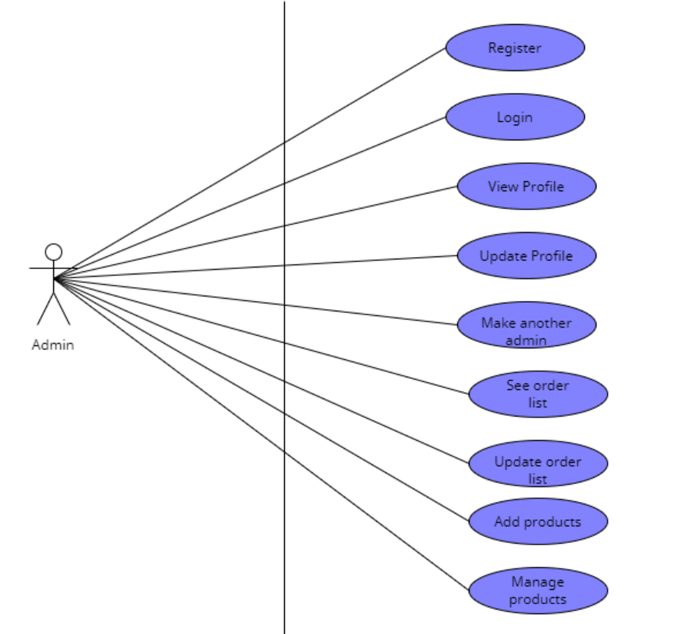

The functionality of an admin is as follows:

The Admin shall be able to login using by filling up the email and password field  
The Admin shall be able to able to create a new admin by inputting his email  
The Admin shall be able to view orders made by a customer   
The Admin shall be able to change the status of an order using a dropdown  
The Admin shall be able to add a new product by inputting the product details in a form  
The Admin shall be able to delete products by clicking the delete button on a product

#### 3.2.2 Customer Functionality:

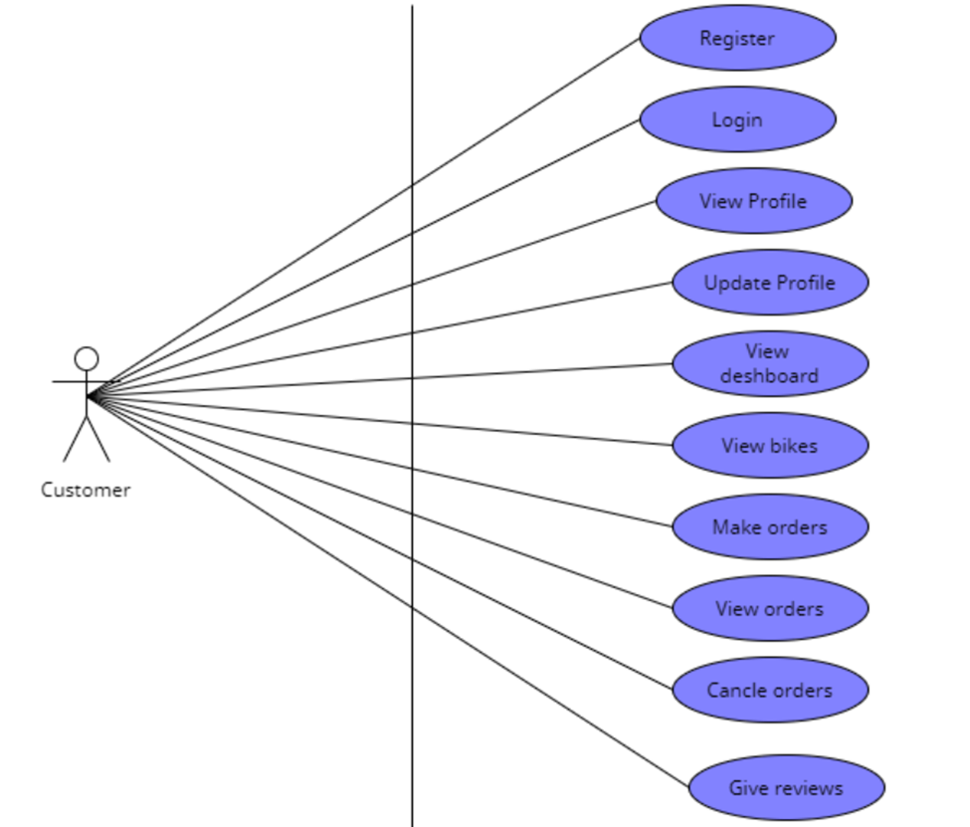

The function of Customer is such as:

The user shall be able to order a bike by filling out name phone and address input fields   
The User shall be able to change profile details by changing the text field and clicking on update   
The user shall be able to login using google login  
The user shall be able to register using email and password   
The user shall be able to view order status in his profile

## 3.3 Performance Requirements

Performance requirements are plays a vital role in any software, and its Software Requirements Specifications (SRS) document because it explains how the software works with its best outcomes. Bike Ecommerce Store software is a system that provides an automatic system or process that is used by a customer for ordering bikes at favorable prices. Here, the admin can track all details, changes details if he needs, and also modify prices or details, and so on. Every option is fully customizable admin or customer can choose whatever they want and even can modify also.

·       Customer can find all accurate details of his or her desire product.

·       No hassle for order.

·       System notify to the admin as well as customer also.

·       Wireless order system.

·       Eco friendly.

·       Admin can manage everything smoothly with proper instructions.

·       Automatic order and prices are calculated.

·       Customer shall not need to visit showroom.

·       Shall not need to go bank for transaction.

## 3.4 Logical Database Requirements

ER diagram of the database requirements is given below

#### Admin ER diagram:

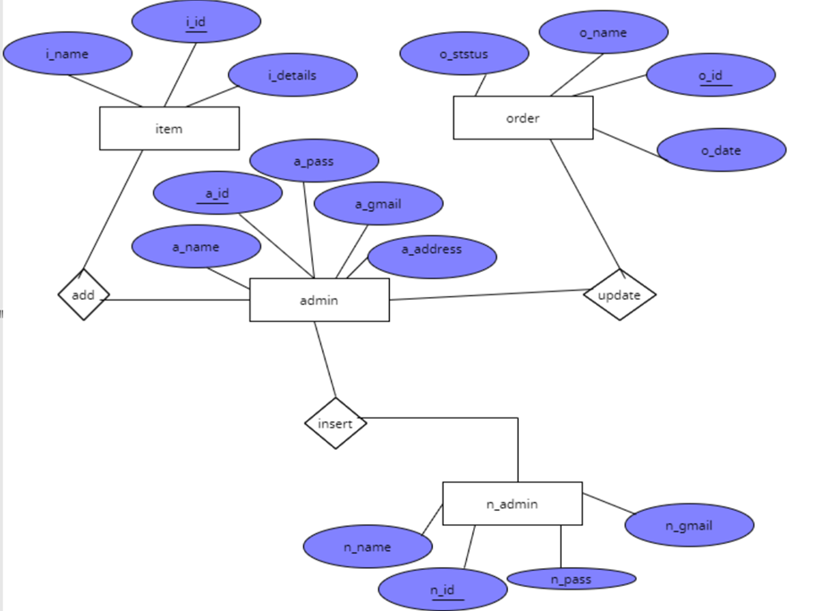

**Customer ER diagram**

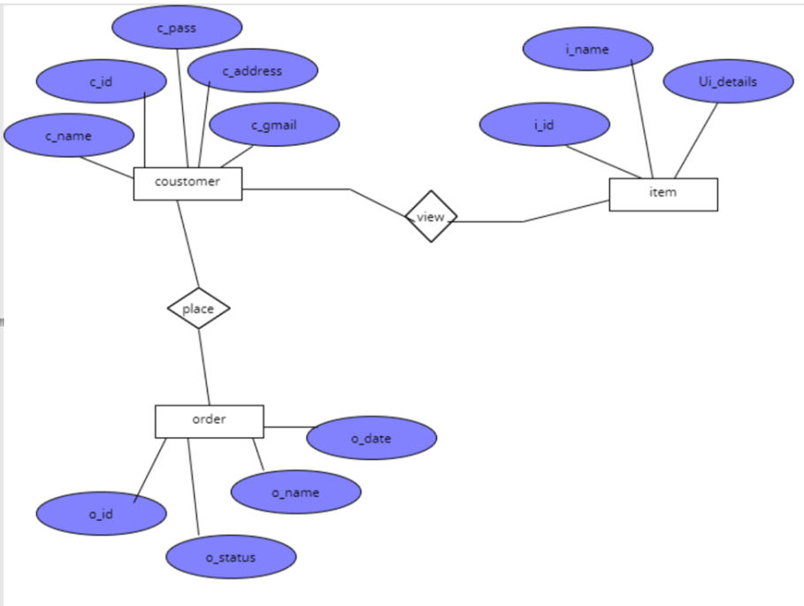

## 3.5 Design Constraints

Like other software Bikes Ecommerce Store have some design or other constraints also. Therefore some arrival design constraints are given below;

* Usages of outside regulation: Usually, the data passes from client to server through TCP/IP system or protocol but this software is not used any type of public-key encryption service such as Secure Sockets Layer (SSL) certificate. For this reason, this software has constraints to passing user data and causes for confidentiality, and integrity causes.
* Bandwidth limitations: This constraint may lose some server connection for a few technical mistakes (Sometimes depends on Hardware or Internet connection). For this cause, it needs to run the query afresh.
* Databases: JSON file is used in this software that user queries have more than servers’ limitations that it needs to observe and fresh table data or information. In this incident, there has a lack of DB caching.
* Communication protocols: For communication protocols, TCP/IP is used to interact with the server, and another protocol is not considered for user demand.
* Parallel operations: The parallel use of other internet applications with this software or project may hamper its bandwidth, and also may occur in the taking time for a query for slow connections.

### 3.5.1 Standards Compliance

For the standards compliance, it may cause (In case of Internet Security):

**·       Confidentiality problem:** Here, sometimes the user, intended server fails “understanding” message contents and types.

**·       Integrity problem:** Hither, the sender, server may fail to ensure message not altered without detection.

**·       Authentication problem:** Server may not recognize/confirm actual valid user.

**·       Impersonation:** Can fake (spoof) source address in packet (or any field in packet).

**·       Denial of service:** Prevent service from being used by others (e.g., by overloading resources).

**·       Eavesdrop:** There may be Intercept messaging, actively insert messages into connection.

## 3.6 Software System Attributes

### 3.6.1 Reliability

Sometimes little third-party software is tried to use to build up this software or project. Therefore, these are free components; most of them are indicated as open source. This software has used a strong database component named JSON for protecting strongly, for this reason, this software will not affect by others. Moreover, this software is not used other things that indicate illegal, so it is the most reliable software to use frankly.

### 3.6.2 Availability

System’s availability requirements:

·       User must have basic knowledge how to use computer or smart phone.

·       Every device must have internet connection.

·       The user must know English language for operate device properly, as the user   interface will be provided in English.

·       Every device must have enough hardware resource for run the software.

### 3.6.3 Security

### System’s security requirements:

### ·       User authentication is required to access the system.

### ·       A client or user must be a registered user to login to use the features of the Bike Ecommerce Store.

### ·       Without proper authentication no one can login to the system or use the features.

### 3.6.4 Maintainability

OOP principles must be followed to make sure the system is maintainable and extendable.

### 3.6.5 Portability

The eCommerce site will run on a webserver and accessed by a browser. Thus as long as a machine can run a JS enabled browser it can access the system.

|  |  |  |  |  |  |  |  |  |  |  |  |  |  |  |
| --- | --- | --- | --- | --- | --- | --- | --- | --- | --- | --- | --- | --- | --- | --- |
| **ID** | **Characteristic** | **H/M/L** | **1** | **2** | **3** | **4** | **5** | **6** | **7** | **8** | **9** | **10** | **11** | **12** |
| 1 | Correctness |  | H |  |  |  |  |  |  |  |  |  |  |  |
| 2 | Efficiency |  | M | L |  |  |  |  |  |  |  |  |  |  |
| 3 | Flexibility |  | M | L | M |  |  |  |  |  |  |  |  |  |
| 4 | Integrity/Security |  | H | L | M | H |  |  |  |  |  |  |  |  |
| 5 | Interoperability |  | H | M | M | H |  |  |  |  |  |  |  |  |
| 6 | Maintainability |  | H | M | H | L |  |  |  |  |  |  |  |  |
| 7 | Portability |  | L | H | H | L |  |  |  |  |  |  |  |  |
| 8 | Reliability |  | H | H | H | M |  |  |  |  |  |  |  |  |
| 9 | Reusability |  | L | L | H | H |  |  |  |  |  |  |  |  |
| 10 | Testability |  | L | H | H | L |  |  |  |  |  |  |  |  |
| 11 | Usability |  | M | M | L | M |  |  |  |  |  |  |  |  |
| 12 | Availability |  | H | M | L | H |  |  |  |  |  |  |  |  |

## 

## 3.7 Organizing the Specific Requirements

The organizing the specific requirements potion is talking about the Bike Ecommerce Store organizing requirements and getting familiar with its best system or every function.

### 3.7.1 System Mode

**DeshBoard**

·       Can view Bikes advertisement.

·       Can order Bike.

·       Can view reviews.

·       Can find signup or sign in options.

·       Can trace contract.

·       Can know about this software.

·       Can subscribe.

**Admin**

**·** Can register.

·       Can login.

·       Can view profile.

·       Can update profile.

·       Can make another admin.

·       Can see order list.

·       Can update order list.

·       Can add products.

·       Can manage products.

**Customer**

**·** Can register.

·       Can login.

·       Can view profile.

·       Can update profile.

·       Can view dashboard.

·       Can view bikes.

·       Can make order.

·       Can view orders.

·       Can cancel orders.

·       Can give reviews.

### 3.7.2 User Class

There are two user classes. The customer who orders the bike and the admin.





### 3.7.3 Objects

*Objects are real-world entities that have a counterpart within the system. Associated with each object is a set of attributes and functions. These functions are also called services, methods, or processes. Note that sets of objects may share attributes and services. These are grouped together as classes.*

### 3.7.4 Feature

**Admin**

**·** Can register.

·   Can login.

·   Can view profile.

·   Can update profile.

·   Can make another admin.

·   Can see order list.

·   Can update order list.

·   Can add products.

·   Can manage products.

**Customer**

**·** Can register.

·       Can login.

·       Can view profile.

·       Can update profile.

·       Can view dashboard.

·       Can view bikes.

·       Can make order.

·       Can view orders.

·       Can cancel orders.

  Can give reviews

### 3.7.5 Stimulus

In the stimulus part, one can say that the admin system or feature is one of the best-organized processes in the Bike Ecommerce Store software. Here, an admin can maintain his or her all systematic work by logging in with a valid id and password to the software or system. Moreover, the admin has several functions such as updating the profile, making another admin, adding new products, managing products, and most importantly working with the delivery system also. Therefore, admin is the heart of this software. For this reason, one can say that the work of the admin is more important in terms of stimulus.

### 3. 7.6 Response

This software or application will have a graphical user interface, where the registered users can use it from any browser and so it is browser independent.

·       The working modules:

1)    Admin(owner)

2)    Customer

·       The system will store the information of all registered users information, customer orders, and bike details, income of the software, place order information and accurate calculation.

·       As the admin, has to login to the system, it means there is an authenticated & secure login system and secure data transmission for all users.

### 3.7.7 Functional Hierarchy

The Bike Ecommerce Store software can make a functional hierarchy whenever they need extra employees as their requirements. But at present admin can make another admin if he or she wants and other things customers can add or create their ID by themselves.

## 3.8 Additional Comments

For the Bike Ecommerce Store, if any feature or employee add or remove then few options, function will be change. Therefore functional hierarchy will be effected and alternative also.

# Change Management Process

Change Management Process is a process that depends on system or software changes or additions. If the Bike Ecommerce Store changes its management process it will not hamper its performance and other things. It still capable,

·       To make satisfy the clients.

·       To consume time.

·       To finds brand new bikes.

·       To help reduce the usage of labour, as tasks such as having to take orders from customers is eliminated.

·       To less chances of data being lost or incorrect data entry.

·       To efficient, smooth and easy procedure of running a e-commerce site.

·       To make faster orders.

The admin (owner) can monitor the Bike Ecommerce Store easily from any location.

# Document Approvals

**LETTER OF APPROVAL**

11th June, 2022.

To,

MR. R

Associate Professor Computer science and engineering,

American International University of Bangladesh (AIUB)

Sir,

We have prepared the report on Software Requirements Specification of 'Bike E-commerce Store' for your approval. This report details the requirements we gathered for the project.

The primary purpose of this report is to summarize our findings from the work that we completed as our Software documentation and tools course project. This report includes the details of each step we followed to collect the requirements.

Sincerely Yours,

MD. REAZ UDDIN CHOWDHURY (21-92155-3)

UMMEY SOAIBA YEASMIN (21-92158-3)

AKIBUR RAHMAN AKIB (22-92573-2)

SHEULY AKTER (22-92609-2)

MD. RIFAT UZ ZAMAN (22-92610-2)

**Approved By: MR. R**

**MR.R**

**11-06-22**

# Supporting Information

*The supporting information makes the SRS easier to use. It includes:*

1. *Table of Contents*
2. *Index*
3. *Appendices*

*The Appendices are not always considered part of the actual requirements specification and are not always necessary. They may include:*

*(a) Sample I/O formats, descriptions of cost analysis studies, results of user surveys*

*(b) Supporting or background information that can help the readers of the SRS*

*(c) A description of the problems to be solved by the software*

*(d) Special packaging instructions for the code and the media to meet security, export, initial loading, or other requirements*

*When Appendices are included, the SRS should explicitly state whether or not the Appendices are to be considered part of the requirements.*

Tables on the following pages provide alternate ways to structure section 3 on the specific requirements. You should pick the best one of these to organize section 3 requirements.